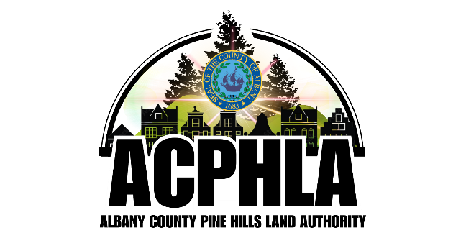
Albany County Pine Hills Land Authority
Governance Committee Meeting

Thursday, May 14, 2026, at 10:00 AM
1009 Madison Avenue, Albany, NY 12208

AGENDA

- Call to Order & Roll Call Jasmine Higgins, Chair
- Meeting Minutes Review – December 11, 2025

- Review of Public Document Postings Thomas Owens, Esq.
on ACPHLA Website
- Submission of Financial Disclosure Forms Reminder
(Forms Available For Members, if needed)

- Executive Session (if necessary) Jasmine Higgins, Chair
- Adjournment Jasmine Higgins, Chair

