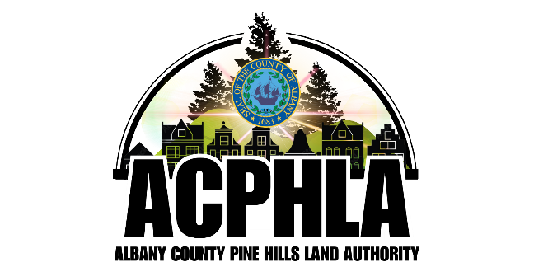
Albany County Pine Hills Land Authority
Board of Directors Meeting
Thursday, May 14, 2025, at 10:15 AM
1009 Madison Avenue, Albany, NY 12208

AGENDA

- Call to Order & Roll Call Alison Walsh, Chair

- Board of Directors Vice Chair Nomination Alison Walsh, Chair

  - (action) Resolution 2026-05-01

- Meeting Minutes Review – April 9, 2026 Alison Walsh, Chair

- Public Comments Alison Walsh, Chair

- CFO Report Dave Reilly, CFO

  - March 2026 Financials Dave Reilly, CFO

- CEO Report Michael Lalli, CEO

  - Management/Operations Transition from AACA to the County

  - Potential Disposition of the Massry Center for Arts
to Hudson Valley Community College Foundation

  - Potential Farmer's Market (Mr. Scott Abraham)

- Other Business Alison Walsh, Chair

  - (action) Resolution 2026-05-02
(Authorize Amendment of Operations Funding Agreement
Related to County Approvals of Authority Reimbursement Requests)

- Executive Session (if necessary) Alison Walsh, Chair

- Adjournment Alison Walsh, Chair

